Logic Gates – Definition, Types, Uses
- m

Logic Gates are the fundamental building blocks in digital electronics. There are basically seven main types of logic gates which are used to perform various logical operations in digital systems. By combining different logic gates complex operations are performed and circuits like flip-flop, counters, and processors are designed. In this article we will see various types of logic gates in detail.
Table of Content
- What is a Logic Gate?
- Types of Logic Gates
- AND GATE
- OR GATE
- NOT GATE
- NOR GATE
- NAND GATE
- XOR GATE
- XNOR GATE
- Applications of Logic Gates
- Advantages of Logic Gates
- Di​sadvantages of Logic Gates
- Conclusion
- Frequently Asked Questions on Logic Gates – Definition, Types, Uses – FAQs

What is a Logic Gate?

A logic gates are an electronic circuit that are designed by using electrical components like diodes, transistors, resistors, and more. It is used to perform logical operations based on the inputs provided to it and gives logical output that can be either high(1) or low(0). The operation of logic gates is based on the Boolean algebra or mathematics. Logic gate founds its uses in our day to day basis such as in the architecture of our telephone, laptops, tablets an memory devices.

Types of Logic Gates
Logic gates can be broadly classified into three main categories

AND GATE
An AND gate is used to perform logical Multiplication of binary input. The Output state of the AND gate will be high(1) if both the input are high(1) ,else the output state will be low(0) if any of the input is low(0).
The Boolean Expression or logic for the AND gate is the logical multiplication of inputs denoted by a full stop or single dot as
A.B=X
The value of X will be True when both the inputs will be True.
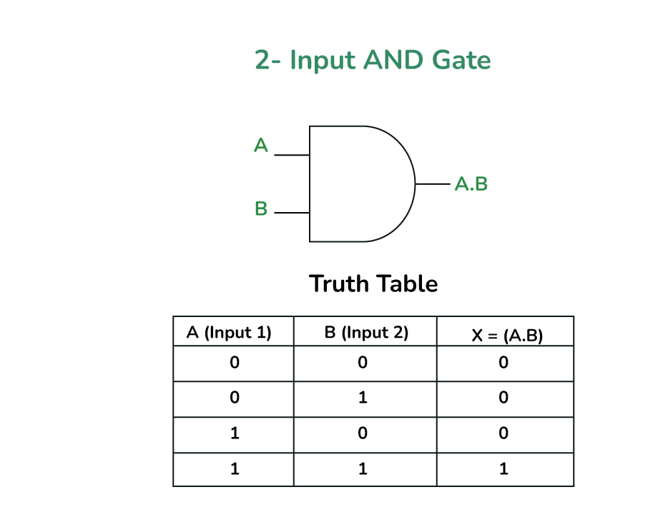

Properties of AND Gate
The following are two main properties of the AND gate
- AND gate can accept two or more than two input values at a time.
- When all of the inputs are logic 1, the output of this gate is logic 1.

OR GATE
OR GATE is most widely used digital logic circuit. The output state of OR gate will be high i.e.,(1) if any of the input state is high or 1, else output state will be low i.e., 0.
The Boolean Expression for the OR gate is the logical addition of inputs denoted by plus sign(+) as
X= A+B
The value of X will be high(true) when one of the inputs is set to high (true).
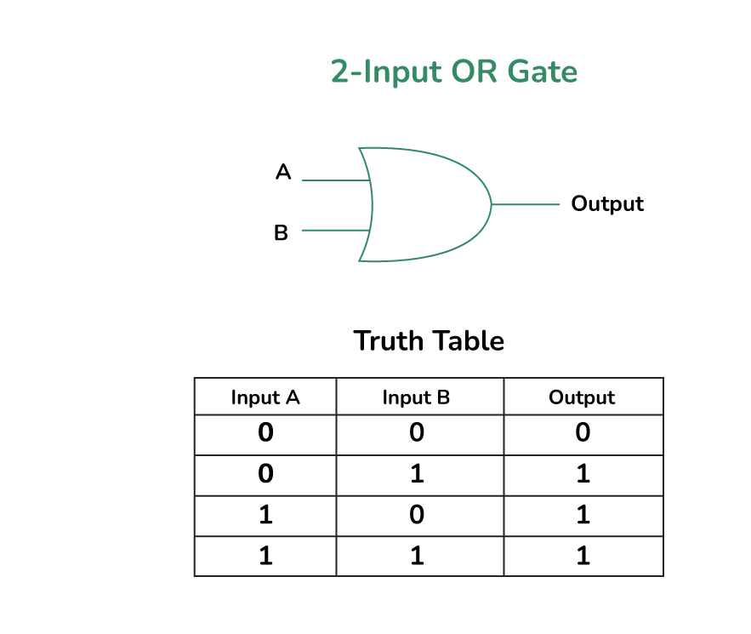

Properties of OR Gate
An OR gate have the following two properties:
- It can have two or more input lines at a time.
- When all of the inputs to the OR gate are low or logic 0, the output of it is low or logic 0.

NOT GATE
In digital electronics, the NOT gate is one of the basic logic gate having only a single input and a single output. It is also known as inverter or inverting buffer. When the input signal is “low” the output signal is “high” and vice-versa.
The Boolean expression of NOT Gate is as follows
Y = Ā or
Y = A’
the value of Y will be high when A will be low.
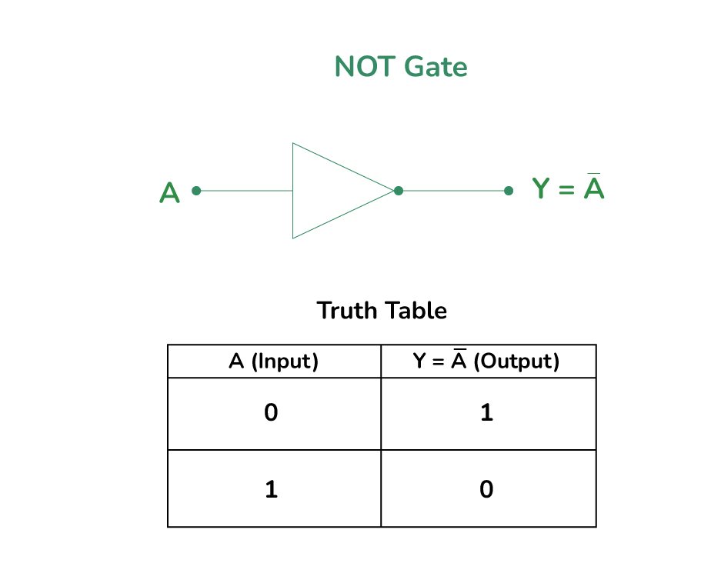

Properties of NOT Gate
- The output of a NOT gate is complement or inverse of the input applied to it.
- NOT gate takes only one output.

NOR GATE
The NOR gate is the type of universal logic gate. It takes two or more inputs and gives only one output. The output state of the NOR gate will be high(1) when all the inputs are low(0). NOR gate returns the complement result of the OR gate. It is basically a combination of two basic logic gates i.e., OR gate and NOT gate.
The Boolean expression of NOR gate is as follows :
If A and B are considered as two inputs, and O as output, then the expression for a two input NOR gate will be
O = (A + B)’
The value of O will be true when all of its inputs are set to 0.
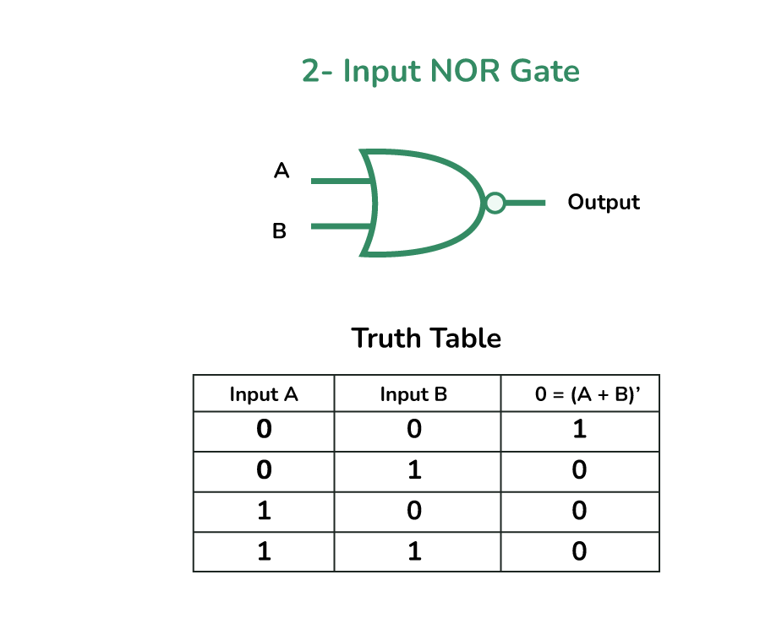

Properties of NOR Gate
The following are two important properties of NOR gate:
- A NOR gate can have two or more inputs and gives an output.
- A NOR gate gives a high or logic 1 output only when its all inputs are low or logic 0.

NAND GATE
The NAND Gate is another type of Universal logic gate. The NAND gate or “Not AND” is the combination of two basic logic gates AND gate and the NOT gate connected in series. It takes two or more inputs and gives only one output. The output of the NAND gate will give result high(1) when either of its input is high(1) or both of its input are low(0). In simple, it performs the inverted operation of AND gate.
The Boolean Expression of NAND Gate is as follows
Say we have two inputs, A and B and the output is called X, then the expression is
X = (A . B)’
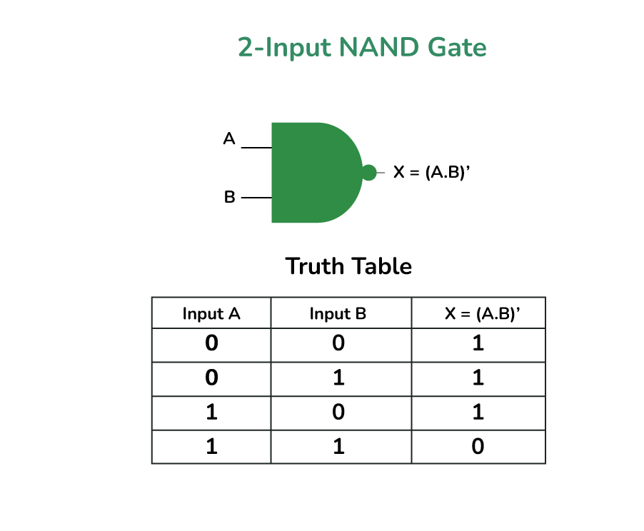

Properties of NAND Gate
The following are the two key properties of NAND Gate
- NAND gate can take two or more inputs at a time and produces one output based on the combination of inputs applied.
- NAND gate produces a low or logic 0 output only when its all inputs are high or logic 1.

XOR GATE
In digital electronics, there is a specially designed logic gate named, XOR gate, which is used in digital circuits to perform modulo sum. It is also referred to as Exclusive OR gate or Ex-OR gate. it is used extensively in arithmetic logic circuits., logic comparators and error detection circuits. The XOR gate can take only two inputs at a time and give an output. The output of the XOR gate is high(1) only when its two inputs are dissimilar i.e., if one of them is low(0) then other one will be high(1).
Say we have two inputs, A and B and the output is called X, then the expression is
The Boolean expression of XOR Gate is as follows
X = A’B + AB’
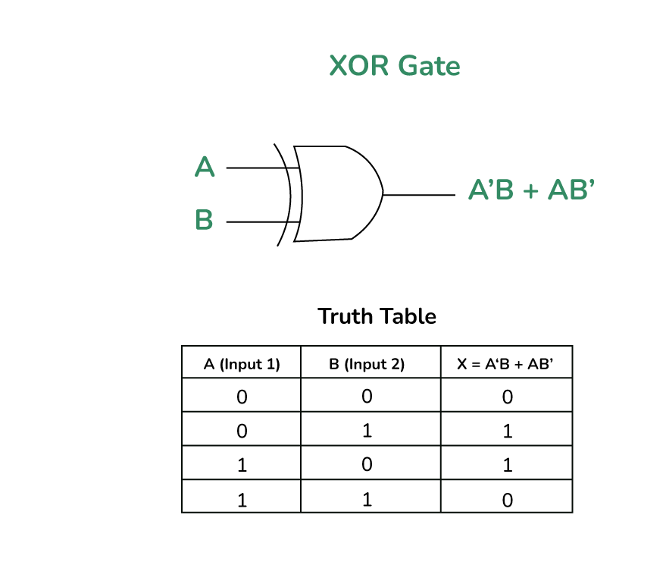

Properties of XOR Gate
The following two are the main properties of the XOR gate:
- It can accept only two inputs at a time. There is nothing like a three or more input XOR gate.
- The output of the XOR gate is logic 1 or high, when its inputs are dissimilar.

XNOR GATE
The XNOR is the combination of XOR gate and NOT gate. The output of the XNOR gate is high(1) when both the inputs are high(1) or low(0). In other words, the output of the XNOR gate is high(1) when both the inputs are the same. the XNOR gate can be sometimes be called as Equivalence gate. In simple words, The XNOR gate is the complement of the XOR gate.
The following is the Boolean expression of the XNOR gate,
Y = A ⊙ B
Here, A and B are the input variables and Y is the output variable.
This expression can also be written as follows,
Y = AB + A’B’
We can also express the operation of an XNOR gate using XOR gate logic as follows:
Y = (A ⊕ B)’

Properties of XNOR Gate
The following are two key properties of XNOR gate:
- XNOR gate takes only two inputs and produces one output.
- The output of the XNOR gate is high or logic 1 only when it has similar inputs.

Applications of Logic Gates
Logic gates are the fundamental building blocks of all digital circuits and devices like computers. Here are some key digital devices in which logic gates are utilized to design their circuits.
- Computers
- Microprocessors
- Microcontrollers
- Digital and smart watches
- Smartphones, etc.

Advantages of Logic Gates
- ​Basic Functions : Logic gates carry out basic logical functions like AND, OR, NOT, XOR, NAND, and NOR. All digital operations and dat respective processing rely on these functions.
- ​Speed : Their extremely high speed rates make them an essential feature in today’s information processing systems that aim for quickness in data analysis.
- Reliability : Being elements whose behaviors are accurately defined means there is no uncertainty about how they behave when used as part of a system.
- Scalability : Digital systems complexity increases by interconnecting and replicating these components without significant variations in size or complexity.
- Low Cost : Logic Gate costs are relatively low from production viewpoint thus making it popular among those who want to construct digital circuits inexpensively.
- Low Power Consumption : Power consumption is minimal with logic gates; hence less energy is needed for operating hence suitable for use with gadgets without batteries or devices running low power consumption applications at all times.

Disadvantages of Logic Gates
Despite their numerous advantages, logic gates have their disadvantages. The following paragraphs discuss some shortcomings of logic gates.
- Complexity : The advancement and complexity of digital systems results in increasing number of logic gates and their interconnections, which causes designs that are very difficult to handle and troubleshoot.
- Propagation Delay : Small delay in the propagating signal is introduced with every logic gate. When several such gates are chained together, these delays can add up and have adverse effects on the overall speed and performance of the circuit.
- Noise Sensitivity : Even noise, interference, and interfering fields can make logic gates sensitive to errors in the output signal. Proper shielding and conditioning of signals at times are needed to reduce these effects.
- Power Dissipation : While logic gates are essentially low power, their dissipation can grow with the complexity of the circuit. Heavy energy loss can generate thermal energy which necessitates supplementary cooling systems.

Conclusion
In this article we have learned about different types of logic gates such as AND ,OR, XOR,etc along with their properties and Advantages and disadvantages. These gates are often combined to build complex digital circuits like multiplexers, adders, and memory units.

